Welcome to Town & Campus Apartments!

Name: _________________________Today’s date: _______________ Move-in date: ______________
Address: ________________________________________________________________________________
Phone(Home)______________________ (Work)___________________ (Cell)______________________
Employer: _________________________________ Occupation: ______________ Income: ______________
E-mail:
How did you hear about us? (Please check one)
ApartmentGuide.com Apartment Finder Apartments.com Referral by: _____________
townandcampusapts.com Signage Other

Type of Apartment Desired: 1 BR 2 BR 3 BR
Number of Occupants: ____________ Children: Yes No
Marital Status: Married Single Divorced Are you smoking: Yes No Animal ( Limit one, NO DOGS): Yes No If yes, What kind of animal:

To Be Completed After Tour
Have you seen all the apartments you desire to see? Yes No
Have you had the opportunity to see the entire apartment community? Yes No
It is our policy to provide apartments to perspective residents without regard to race, sex, color, religion, national origin, familial status, or handicap. In your opinion, have we conducted ourselves in a manner consistent with this policy? Yes No

-----------------------------------------------------------------------------------------------------------------------------------------

OFFICE USE ONLY

Visit Telephone Inquiry Apartment shown by: ________________________

Type of Apartment shown: ________________ Apartment(s) # ________________________

Follow-up information: __________________________________________________________________________________________________

______________________________________________________________________________________________________________________________________

______________________________________________________________________________________________________________________________________

______________________________________________________________________________________________________________________________________

Floor Plans 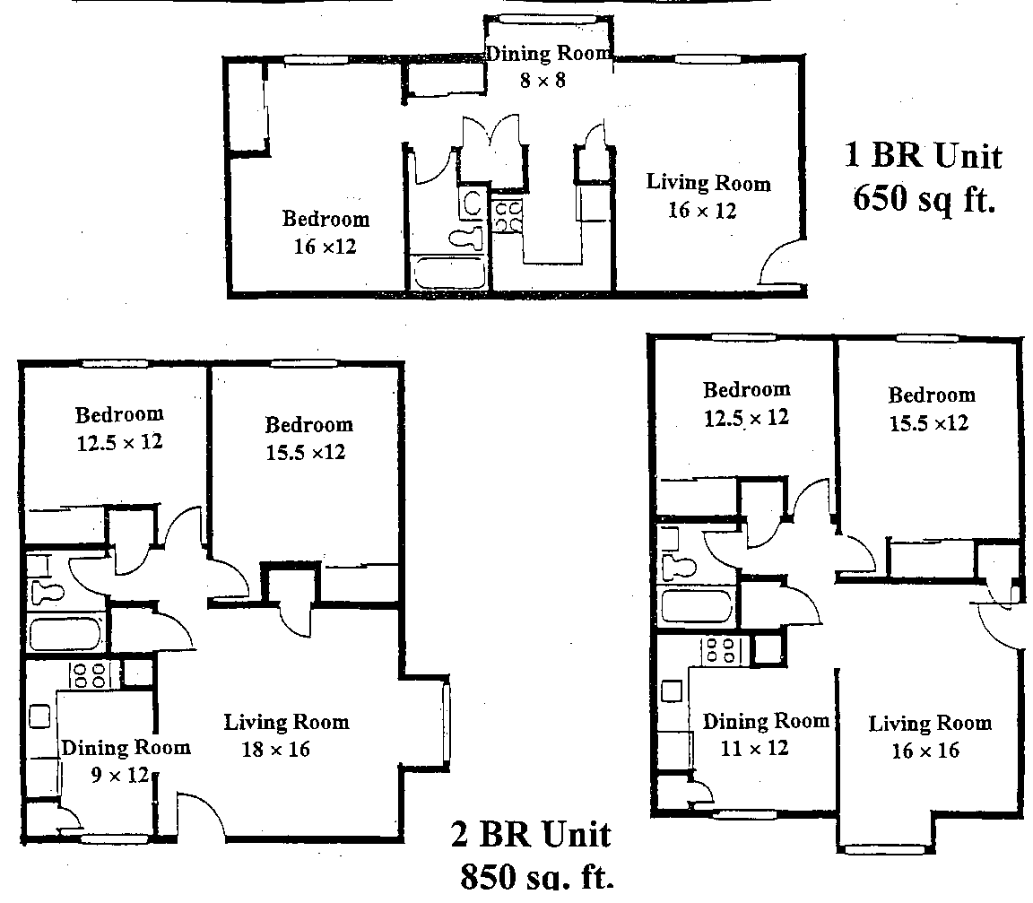

EVERY APARTMENT INCLUDES:

- Kitchen appliance package including frost-free refrigerator, dishwasher, gas range and garbage disposal
- Solid wood entry doors, door viewer and dead bolt; brass handle set and address numerals for each home
- All living rooms wired for High Speed Internet
and cable television
- Large windows for an open, airy feel
- Pantry and linen closet for extra storage
- Central heat and air conditioning, smoke detector and fire extinguisher
- Mini-blinds for all windows, vertical blinds for
2 BR living room windows
- Private outside entrances
- Electric outlets on every wall for added convenience

COMMUNITY AND AREA FEATURES:

- One and two bedroom floor plans to select from
- On-site coin operated laundry facilities
- Close to grocery store, shopping, post office, Banks, and parks
- Close to MSU, Drury, Evangel and OTC
- Located in the Bingham, Hickory, and Glendale school districts
- Superbly designed, manicured and landscaped grounds
- For your living pleasure: a junior Olympic swimming pool
- Large, accessible parking lots
- Close to the Springfield city bus line
- Quiet, sheltered community, with easy and convenient access to city
- Professional, on-site management
- 24 hour emergency maintenance

One - Time Expenses

We require two checks or money orders with Application: $30 and $290

- Application Fee (non-refundable): $30 /per person
- Security Deposit (refundable): $100/per person
- Administrative Fee (non-refundable): $190/ per person

- Pet Fee: $250 (non-refundable, limit one animal in select unit) plus $25

monthly pet rent.

It is understood that the $290 will be returned if the application is not approved.

If the applicant(s) is accepted & fails to sign the lease, the $290 will not be refunded.
If the applicant(s) wants to cancel the lease after it has been signed, not only the $290 will not be refunded and also the cancellation fees will be charged as same as one month’s rent.

Prospect Signature: _____________________________ Date: ______________

Town & Campus Apts. Management: ___________________ Date: ______________

CRITERIA SHEET

This resident selection criterion will be applied to every applicant that wishes to live at Town and Campus Apartments. Applications must be signed by all adult household members. The management will do landlord, credit checks, background etc., along with income verifications in the processing of each applicant.

Selection:

1. AGE: Must be 18 years of age. No exceptions.

2. INCOME: Total household net income must be at least 3 times the
amount of the apartments monthly rental rate.

3. EMPLOYMENT: Prospective residents must be employed by the same employer
for no less than six (6) months. Should a prospect be recently
transferred or relocated, they must have six (6) Month prior
verifiable employment with the same employer, and be
currently employed. Employment history of less than 6 months
may be considered with an additional security deposit.

4. RENTAL HISTORY: Minimum of six (6) months previous landlord reference is
Required. Any skips, judgments, evictions, or unpaid
monies due previous landlords or utility companies will be
cause for denial. References will be verified and cannot include
relatives. Rental history of less than 6 months may be
considered with an additional security deposit.

5. CREDIT: Credit checks will be reviewed on an individual basis and may be
cause for denial. Applicant must have verifiable credit and the
Experian credit score not less than 600. There may be flexibility
regarding medical bills, school loans, and discharged bankruptcy.
If a Chapter 13 bankruptcy is filed 24 months prior to an
application it will be grounds for denial of rental application and
cannot be overridden.

6. GUARANTOR A lease guarantor may be accepted for persons who are students
not meeting the above criteria. Guarantor must show proof of monthly net income of at least FOUR TIMES the monthly rental
rate, and must meet all guarantor criteria on the Guarantee Form.

7. FELONIES: Criminal background will be checked. A felony conviction
and or parole/probation, a history of illegal drug association
for any member of the household will be cause for denial.
Any gang association and sexual offense convictions or
convictions involving weapons or violent crimes may be
cause for denial and/or eviction.

8. INITIAL MOVE-IN Applicant must have rent plus security deposit and
PAYMENT: all related fees on date of move-in. All move-ins after
the 25th of the month must pay for the next month’s
rents. No exceptions.

9. SELF-EMPLOYED, If self-employed, retired or disabled, the applicant
RETIRED, DISABLED: must provide copies to the property manager of
tax returns for the previous year and copies of the
three most recent bank statements showing proof
of ability to pay rent for the term of the lease.

10. FALSE OR INCOMPLETE Failure to provide Town & Campus Apartments with
INFORMATION: required references or information needed to process
the application, or willfully giving false or incomplete
information during the application process will be
cause for denial.

11. OCCUPANCY STANDARDS: No more the two (2) persons in 1 BR apartment and
two (2) adults two (2) children in 2 BR apartment.

Prospect: ____________________________________ Date: ____________

Prospect: ____________________________________ Date: ____________

